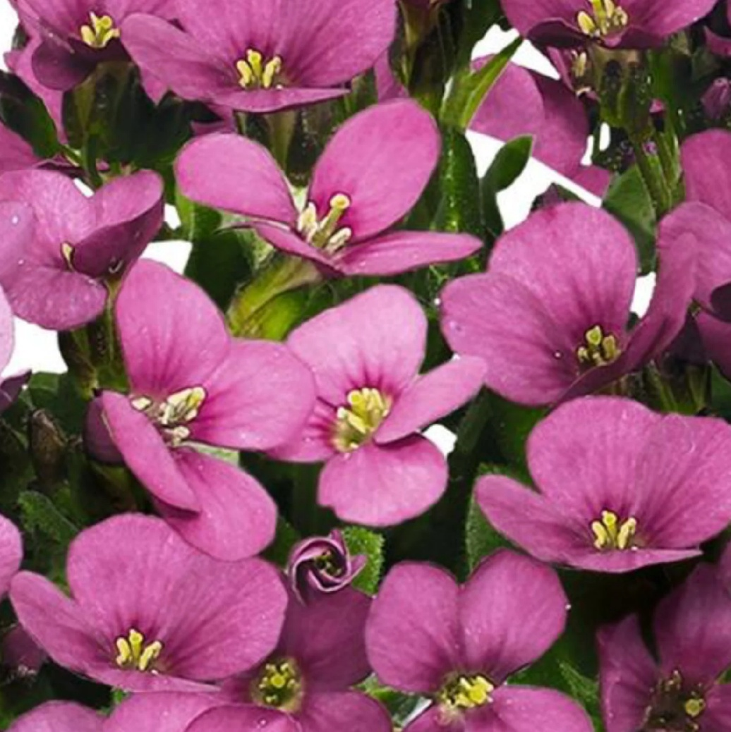






+
To help you identify the different varieties of Wall Cress we write a code on the side of the pot. The code for Catwalk Pink Wall Cress is CP
Arabis ‘Catwalk Pink’
- Forms a tight, mounding cushion of green leaves, bearing masses of sweetly fragrant, pink flowers for several weeks in spring
- Looks great in the rock garden or as an edging or border plant; drought tolerant once established
- Lightly sheer plants after flowering to maintain a compact bushy habit

‘Catwalk Pink’
Wall Cress
Height: 6-8 Inches Zone: 4

